Vertical Line Segment
# Source: AI Source: Provided by: [Data Path: Persons Table -> ID Column: 1, Name_En Column: Motasem Essam] -> From: [ChatGPT] on [7/25/2026]
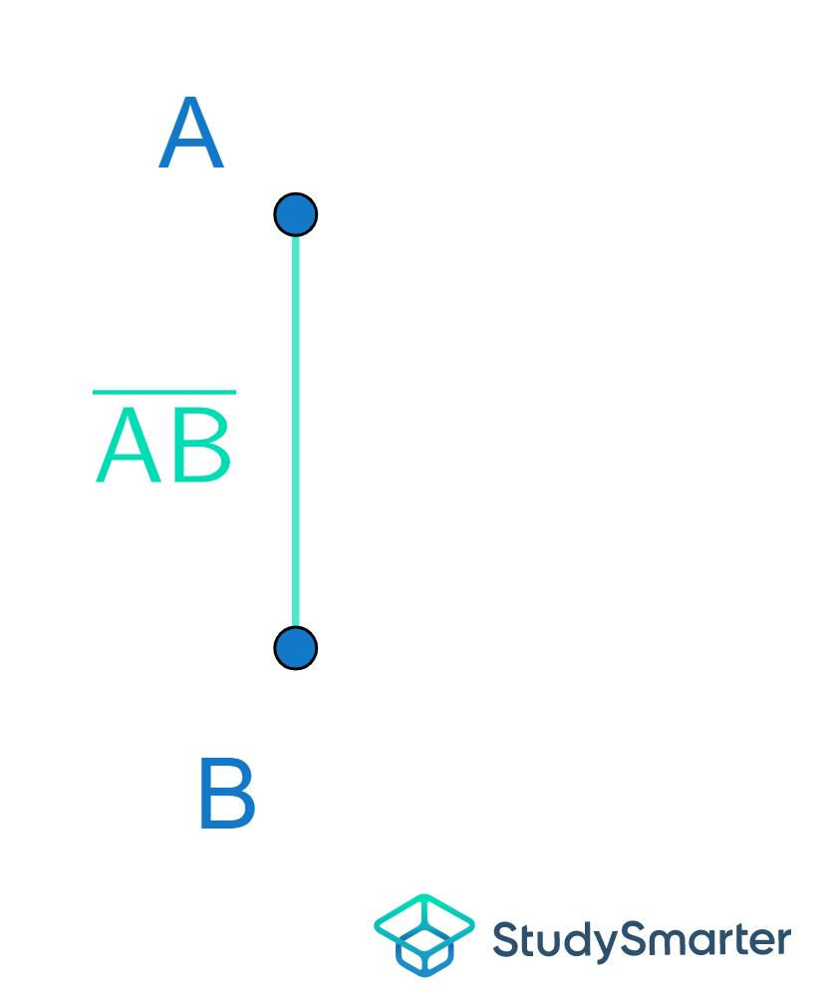
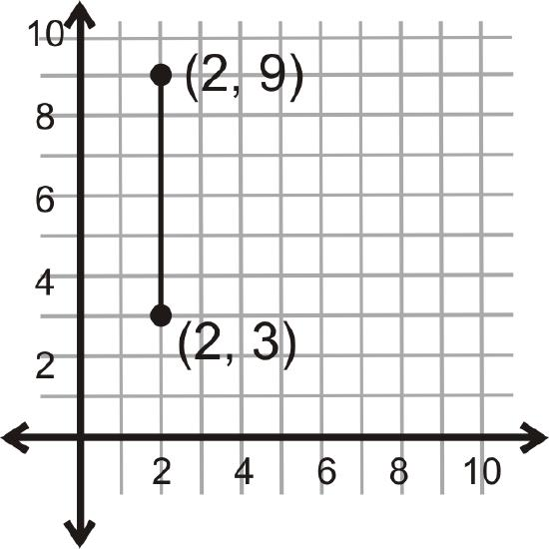
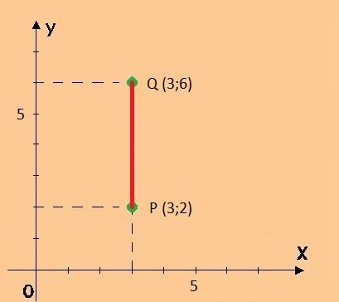
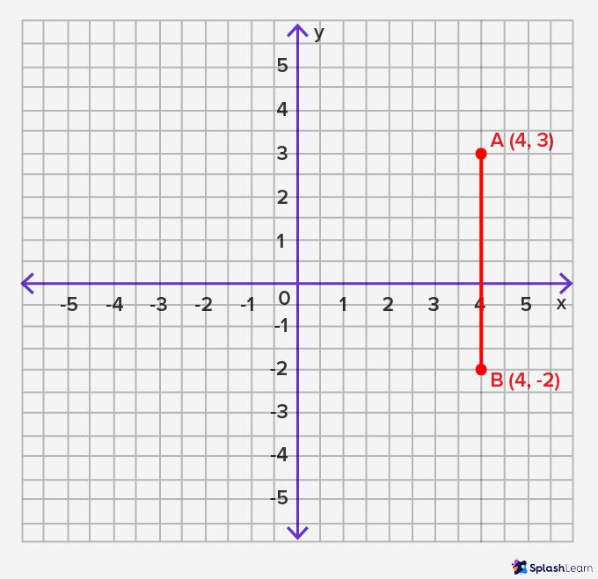

Definition
# Source: AI Source: Provided by: [Data Path: Persons Table -> ID Column: 1, Name_En Column: Motasem Essam] -> From: [ChatGPT] on [7/25/2026]
A Vertical Line Segment is a finite straight line segment whose endpoints have the same x-coordinate. It extends upward and downward between two fixed endpoints, giving it a definite measurable length.
Unlike a vertical line, a vertical line segment does not extend infinitely.

Characteristics
# Source: AI Source: Provided by: [Data Path: Persons Table -> ID Column: 1, Name_En Column: Motasem Essam] -> From: [ChatGPT] on [7/25/2026]
A vertical line segment:
- Has two endpoints.
- Has a finite length.
- Is parallel to the y-axis.
- Has a constant x-coordinate.
- Has an undefined slope.
- Can be measured.

Illustration
# Source: AI Source: Provided by: [Data Path: Persons Table -> ID Column: 1, Name_En Column: Motasem Essam] -> From: [ChatGPT] on [7/25/2026]
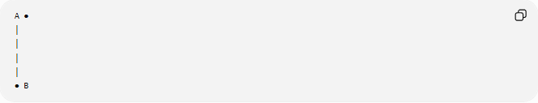
A ●
│
│
│
│
● B
The segment begins at A and ends at B.

Coordinate Geometry
# Source: AI Source: Provided by: [Data Path: Persons Table -> ID Column: 1, Name_En Column: Motasem Essam] -> From: [ChatGPT] on [7/25/2026]
A vertical line segment has endpoints such as:
$$A\left(x , y_{1}\right)$$
and
$$B\left(x , y_{2}\right)$$
where:
$$x_{1}=x_{2}$$

Example
$$A\left(4 , 2\right) \\ B\left(4 , 9\right)$$
Both endpoints have the same x-coordinate:
$$x=4$$
Therefore, the segment is vertical.

Length
The length of a vertical line segment is:
$$AB=∣y_{2}-y_{1}∣$$
since there is no horizontal difference.

Example
If
$$A\left(4 , 2\right)$$
and
$$B\left(4 , 9\right)$$
then
$$AB=∣9-2∣=7$$

Slope
The slope of a vertical line segment is undefined because
$$m=\frac{Δy}{Δx}$$
and
$$Δx=0$$
Division by zero is undefined.

Examples
# Source: AI Source: Provided by: [Data Path: Persons Table -> ID Column: 1, Name_En Column: Motasem Essam] -> From: [ChatGPT] on [7/25/2026]
Examples of vertical line segments include:
- The side edge of a rectangle.
- A flagpole (idealized).
- A building column.
- The edge of a door frame.
- A ruler held upright.

Properties
# Source: AI Source: Provided by: [Data Path: Persons Table -> ID Column: 1, Name_En Column: Motasem Essam] -> From: [ChatGPT] on [7/25/2026]
A vertical line segment:
- Has two endpoints.
- Has finite measurable length.
- Is parallel to the y-axis.
- Has an undefined slope.
- All points on the segment have the same x-coordinate.

Applications
# Source: AI Source: Provided by: [Data Path: Persons Table -> ID Column: 1, Name_En Column: Motasem Essam] -> From: [ChatGPT] on [7/25/2026]
Vertical line segments are used in:
- Plane Geometry
- Coordinate Geometry
- Engineering
- Architecture
- Construction
- CAD (Computer-Aided Design)
- Technical Drawing
- Computer Graphics
- Surveying
- Robotics

Advantages
# Source: AI Source: Provided by: [Data Path: Persons Table -> ID Column: 1, Name_En Column: Motasem Essam] -> From: [ChatGPT] on [7/25/2026]
Studying vertical line segments helps to:
- Measure vertical distances.
- Construct geometric figures.
- Analyze coordinate geometry.
- Create engineering drawings.
- Model upright structural elements.

Limitations
# Source: AI Source: Provided by: [Data Path: Persons Table -> ID Column: 1, Name_En Column: Motasem Essam] -> From: [ChatGPT] on [7/25/2026]
A vertical line segment:
- Has finite length.
- Exists only between its endpoints.
- Represents only one orientation.

Comparison with Related Objects
# Source: AI Source: Provided by: [Data Path: Persons Table -> ID Column: 1, Name_En Column: Motasem Essam] -> From: [ChatGPT] on [7/25/2026]
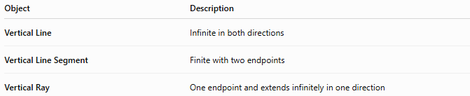
Object | Description
Vertical Line | Infinite in both directions
Vertical Line Segment | Finite with two endpoints
Vertical Ray | One endpoint and extends infinitely in one direction

Key Points
# Source: AI Source: Provided by: [Data Path: Persons Table -> ID Column: 1, Name_En Column: Motasem Essam] -> From: [ChatGPT] on [7/25/2026]
- A Vertical Line Segment is a finite portion of a vertical line.
- It has two endpoints.
- All points have the same x-coordinate.
- Its slope is undefined.
- Its length is:
$$AB=∣y_{2}-y_{1}∣$$
- Vertical line segments are widely used in geometry, engineering, architecture, construction, CAD, surveying, and computer graphics.

Conclusion
# Source: AI Source: Provided by: [Data Path: Persons Table -> ID Column: 1, Name_En Column: Motasem Essam] -> From: [ChatGPT] on [7/25/2026]
A Vertical Line Segment is a finite straight segment whose endpoints share the same horizontal coordinate, making it parallel to the y-axis. Unlike a vertical line, it has a definite measurable length bounded by two endpoints, while its slope remains undefined because there is no horizontal change. Vertical line segments are fundamental in plane geometry, coordinate geometry, engineering, architecture, construction, surveying, CAD, technical drawing, robotics, and computer graphics, where they represent upright edges, vertical distances, and structural components.

